**1.a.Acceptance rate of hosts**

select case

when host_is_superhost = 0 then 'Other Host'

when host_is_superhost = 1 then 'Super Host' end as Host_Category, acceptance as acceptance_rate, sum(acceptance_rate) as counts

from(select host_is_superhost , case

when host_acceptance_rate <= 20 then '0-20'

when host_acceptance_rate >= 21 and host_acceptance_rate <= 40 then '21-40'

when host_acceptance_rate >= 41 and host_acceptance_rate <= 60 then '41-60'

when host_acceptance_rate >= 61 and host_acceptance_rate <= 80 then '61-80'

when host_acceptance_rate >= 81 and host_acceptance_rate <= 100 then '81-100'

end as acceptance

, count(host_acceptance_rate) as acceptance_rate

from host_thessaloniki_df

group by host_is_superhost, host_acceptance_rate

having host_acceptance_rate > 0) as m

group by host_is_superhost ,acceptance

order by host_is_superhost;

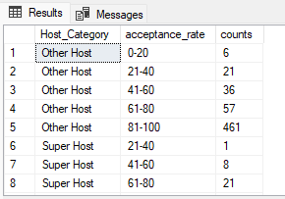

**1.b.Average of Acceptance rate**

select case

when host_is_superhost = 0 then 'Other Host'

when host_is_superhost = 1 then 'Super Host' end as Host_Category , round(Avg(host_acceptance_rate),2) as acceptance_rate

from host_thessaloniki_df

group by host_is_superhost;

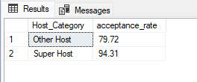

**2.a.Response rate of hosts**

select case

when host_is_superhost = 0 then 'Other Host'

when host_is_superhost = 1 then 'Super Host' end as Host_Category, response as response_rate, sum(response_rate) as counts

from(select host_is_superhost , case

when host_response_rate <= 20 then '0-20'

when host_response_rate >= 21 and host_response_rate <= 40 then '21-40'

when host_response_rate >= 41 and host_response_rate <= 60 then '41-60'

when host_response_rate >= 61 and host_response_rate <= 80 then '61-80'

when host_response_rate >= 81 and host_response_rate <= 100 then '81-100'

end as response

, count(host_response_rate) as response_rate

from host_thessaloniki_df

group by host_is_superhost, host_response_rate

having host_response_rate > 0) as m

group by host_is_superhost ,response

order by host_is_superhost;

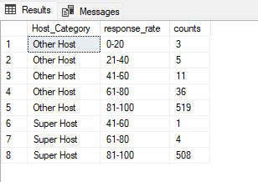

**2.b.Average of Response Rate**

select case

when host_is_superhost = 0 then 'Other Host'

when host_is_superhost = 1 then 'Super Host' end as Host_Category, round(Avg(host_response_rate),2) as response_rate

from host_thessaloniki_df

group by host_is_superhost;

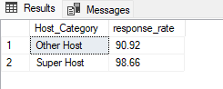

**3.Acceptance rate based on response time of hosts**

select case

when host_is_superhost = 0 then 'Other Host'

when host_is_superhost = 1 then 'Super Host' end as Host_Category, host_response_time as response_time, round(avg(host_acceptance_rate),2) as acceptance_rate

from host_thessaloniki_df

group by host_is_superhost, host_response_time

having count(host_response_time)>1

order by host_is_superhost;

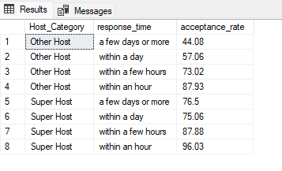

**4.Listings under hosts which are instant bookable or not**

select case

when host_is_superhost = 0 then 'Other Host'

when host_is_superhost = 1 then 'Super Host' end as Host_Category, instant_bookable, count(instant_bookable) as count_of_listings

from host_thessaloniki_df as h

join listing_thessaloniki_df as l

on h.host_id = l.host_id

group by host_is_superhost, instant_bookable;

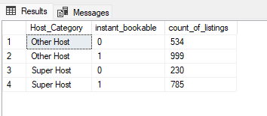

**5.Count of hosts that have profile pic**

select case

when host_is_superhost = 0 then 'Other Host'

when host_is_superhost = 1 then 'Super Host' end as Host_Category, host_has_profile_pic, count(host_has_profile_pic) as count

from host_thessaloniki_df

group by host_is_superhost, host_has_profile_pic;

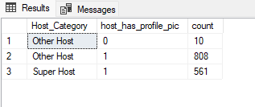

**6.Count of hosts whose identity is verified**

select case

when host_is_superhost = 0 then 'Other Host'

when host_is_superhost = 1 then 'Super Host' end as Host_Category, host_identity_verified, count(host_identity_verified) as count

from host_thessaloniki_df

group by host_is_superhost, host_identity_verified;

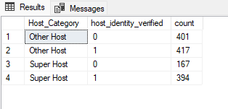

**7.Review score rating of listings which is under hosts**

select case

when host_is_superhost = 0 then 'Other Host'

when host_is_superhost = 1 then 'Super Host' end as Host_Category, round(avg(review_scores_rating),2) as review_score_rating

from host_thessaloniki_df as h

join listing_thessaloniki_df as l

on h.host_id = l.host_id

group by host_is_superhost;

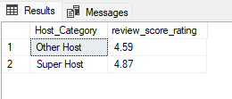

**8.Average no. of booking per month**

select case

when host_is_superhost = 0 then 'Other Host'

when host_is_superhost = 1 then 'Super Host' end as Host_Category, (avg(counts)/10) as avg_bookings_per_month

from(select host_is_superhost, month(date) as months, count(date) as counts

from host_thessaloniki_df as h

join listing_thessaloniki_df as l

on h.host_id = l.host_id

join review_thessaloniki_df as r

on l.id = r.listing_id

group by host_is_superhost, month(date)) as m

group by host_is_superhost;

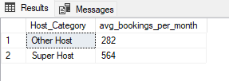

**9.a.Counts of comments by keyword Excellent**

select case

when host_is_superhost = 0 then 'Other Host'

when host_is_superhost = 1 then 'Super Host' end as Host_Category, sum(counts) as Comments_mentioned_Excellent_Keyword

from(select host_is_superhost, count(r.comments) as counts

from host_thessaloniki_df as h

join listing_thessaloniki_df as l

on h.host_id = l.host_id

join review_thessaloniki_df as r

on l.id = r.listing_id

where r.comments like '%Excellent%'

group by h.host_is_superhost, h.host_id,l.name, r.reviewer_name, r.comments) as m

group by host_is_superhost;

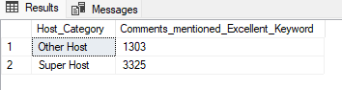

**9.b.Counts of comments by keyword Excellent**

select case

when host_is_superhost = 0 then 'Other Host'

when host_is_superhost = 1 then 'Super Host' end as Host_Category, sum(counts) as Comments_mentioned_Excellent_Keyword

from(select host_is_superhost, count(r.comments) as counts

from host_thessaloniki_df as h

join listing_thessaloniki_df as l

on h.host_id = l.host_id

join review_thessaloniki_df as r

on l.id = r.listing_id

where r.comments like '%Filthy%'

group by h.host_is_superhost, h.host_id,l.name, r.reviewer_name, r.comments) as m

group by host_is_superhost;

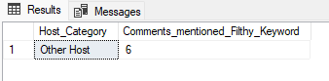

**9.c.Counts of comments by keyword Excellent**

select case

when host_is_superhost = 0 then 'Other Host'

when host_is_superhost = 1 then 'Super Host' end as Host_Category, sum(counts) as Comments_mentioned_Excellent_Keyword

from(select host_is_superhost, count(r.comments) as counts

from host_thessaloniki_df as h

join listing_thessaloniki_df as l

on h.host_id = l.host_id

join review_thessaloniki_df as r

on l.id = r.listing_id

where r.comments like '%Good host%'

group by h.host_is_superhost, h.host_id,l.name, r.reviewer_name, r.comments) as m

group by host_is_superhost;

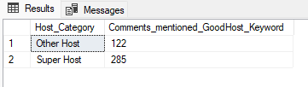

**9.d.Comments varies for hosts**

select case

when host_is_superhost = 0 then 'Other Host'

when host_is_superhost = 1 then 'Super Host' end as Host_Category, h.host_id, l.name, r.reviewer_name, r.comments

from host_thessaloniki_df as h

join listing_thessaloniki_df as l

on h.host_id = l.host_id

join review_thessaloniki_df as r

on l.id = r.listing_id

where r.comments like '%behaviour%'

group by h.host_is_superhost, h.host_id,l.name, r.reviewer_name, r.comments

order by host_is_superhost

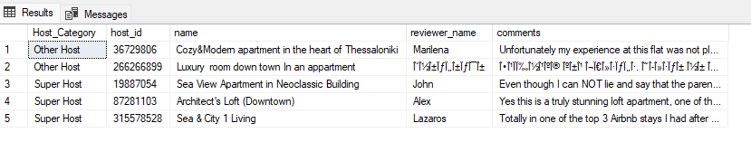

**9.e.Comments by keyword ‘Filthy’**

select top 5 case

when host_is_superhost = 0 then 'Other Host'

when host_is_superhost = 1 then 'Super Host' end as Host_Category,l.name as listing_name, r.reviewer_name, r.comments, r.date

from host_thessaloniki_df as h

join listing_thessaloniki_df as l

on h.host_id = l.host_id

join review_thessaloniki_df as r

on l.id = r.listing_id

where r.comments like '%filthy%'

group by h.host_is_superhost,l.name, r.reviewer_name, r.comments, r.date

having host_is_superhost = 0

order by h.host_is_superhost asc

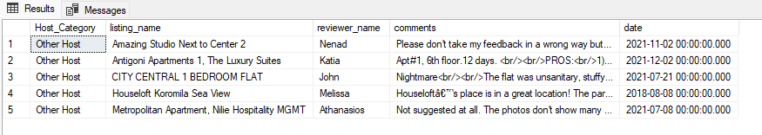

**10.Size of properties**

select case

when host_is_superhost = 0 then 'Other Host'

when host_is_superhost = 1 then 'Super Host' end as Host_Category, l.property_type, count(l.property_type) as counts

from host_thessaloniki_df as h

join listing_thessaloniki_df as l

on h.host_id = l.host_id

group by h.host_is_superhost, l.property_type

having count(l.property_type) > 1

order by host_is_superhost, count(l.property_type)

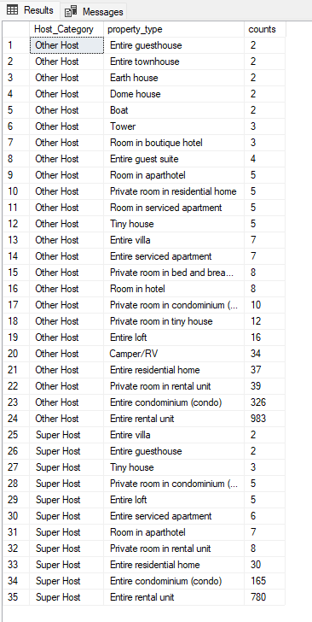

**2)**

**Athens**

**1.a.For Athens Average Price(Super & Other Host)**

select case

when h.host_is_superhost = 0 then 'Other Host'

else 'Super Host'

end as host_is_superhost, round(avg(a.price),2) as Avg_Price_of_Listings

from host_athens_df as h

join listing_athens_df as l

on h.host_id = l.host_id

join df_athens_availability as a

on l.id = a.listing_id

where host_is_superhost>=0 and year(a.date) = 2022

group by host_is_superhost;

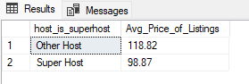

**1.b.For Athens Available Listings(Super & Other Host)**

select case

when h.host_is_superhost = 0 then 'Other Host'

else 'Super Host'

end as host_is_superhost,

case when a.available = 0 then 'Not Available'

else 'Availale'

end as Availability,

count(a.available) as Available_listings

from host_athens_df as h

join listing_athens_df as l

on h.host_id = l.host_id

join df_athens_availability as a

on l.id = a.listing_id

where host_is_superhost>=0 and year(a.date) = 2022

group by host_is_superhost, a.available

order by host_is_superhost;

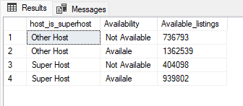

**2.a.For Athens Average Price(Local & Other Location Host)**

select locations, round(avg(price),2) as Avg_Price_of_Listings

from

(select h.host_id, a.price, a.date, case

when h.host_location like '%athens%' then 'Local_host'

else 'Other_Location_Host'

end as locations

from host_athens_df as h

join listing_athens_df as l

on h.host_id = l.host_id

join df_athens_availability as a

on l.id = a.listing_id) as a

where year(a.date) = 2022

group by locations

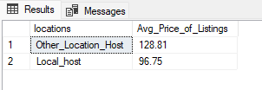

**2.a.For Athens Available Listings(Local & Other Location Host)**

select Host_location, case

when a.available = 0 then 'Not Available'

when a.available = 1 then 'Available'

end as Availability, count(a.available) as Available_Listings

from

(select h.host_id, a.available, a.date, case

when h.host_location like '%athens%' then 'Local_host'

else 'Other_Location_Host'

end as Host_location

from host_athens_df as h

join listing_athens_df as l

on h.host_id = l.host_id

join df_athens_availability as a

on l.id = a.listing_id) as a

where year(a.date) = 2022

group by Host_location, a.available

order by Host_location desc;

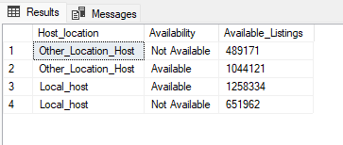

**Thessaloniki**

**3.a.For Thessaloniki Average Price(Super & Other Host)**

select case

when h.host_is_superhost = 0 then 'Other Host'

else 'Super Host'

end as host_is_superhost, round(avg(a.price),2) as Avg_Price_of_Listings

from host_thessaloniki_df as h

join listing_thessaloniki_df as l

on h.host_id = l.host_id

join df_thessaloniki_availability as a

on l.id = a.listing_id

where host_is_superhost>=0 and year(a.date) = 2022

group by host_is_superhost;

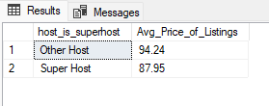

**3.a.For Thessaloniki Available Listings(Super & Other Host)**

select case

when h.host_is_superhost = 0 then 'Other Host'

else 'Super Host'

end as host_is_superhost,

case when a.available = 0 then 'Not Available'

else 'Availale'

end as Availability,count(a.available) as Available_Listings

from host_thessaloniki_df as h

join listing_thessaloniki_df as l

on h.host_id = l.host_id

join df_thessaloniki_availability as a

on l.id = a.listing_id

where host_is_superhost>=0 and year(a.date) = 2022

group by host_is_superhost,a.available

order by h.host_is_superhost;

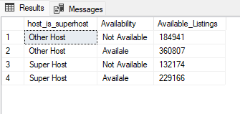

**4.a.For Thessaloniki Average Price(Local & Other Location Host)**

select locations, round(avg(price),2) as Avg_Price_of_Listings

from

(select h.host_id, a.price, a.available, a.date, case

when h.host_location like '%thessaloniki%' then 'Local_host'

else 'Other_Location_Host'

end as locations

from host_thessaloniki_df as h

join listing_thessaloniki_df as l

on h.host_id = l.host_id

join df_thessaloniki_availability as a

on l.id = a.listing_id) as a

where year(a.date) = 2022

group by locations

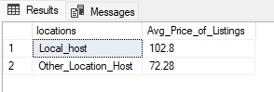

**4.a.For Thessaloniki Available Listings(Local & Other Location Host)**

select Host_location, case

when a.available = 0 then 'Not Available'

when a.available = 1 then 'Available'

end as Availability,

count(available) as Available_Listings

from

(select h.host_id, a.price, a.available, a.date, case

when h.host_location like '%thessaloniki%' then 'Local_host'

else 'Other_Location_Host'

end as Host_location

from host_thessaloniki_df as h

join listing_thessaloniki_df as l

on h.host_id = l.host_id

join df_thessaloniki_availability as a

on l.id = a.listing_id) as a

where year(a.date) = 2022

group by Host_location, a.available

order by Host_location desc;

